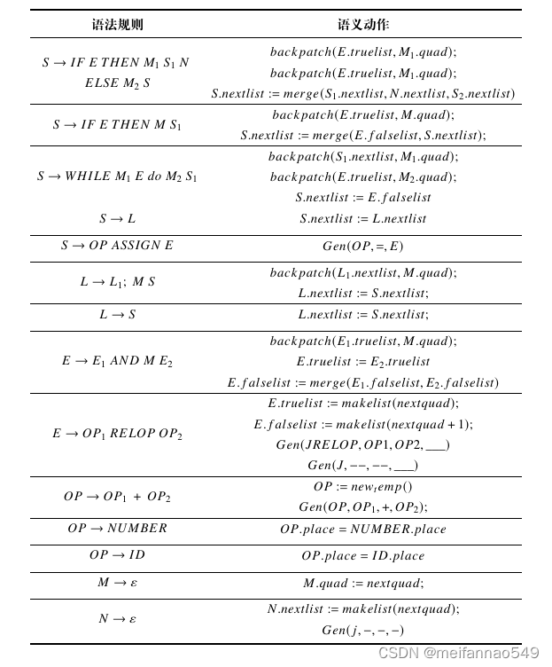

|  |  |
| --- | --- |
| Syntax rule | Semantic action |
| S->IF E THEN M1 S1N  ELSE M2S2 | backpatch (E.truelist, M1.quad)  backpatch (E.truelist, M1.quad)  S.nextlist := merge(S1.nextlist,N.nextlist, S2.nextlist) |
| S->IF E THEN M S1 | backpatch(E.truelist, M.quad);  S.nextlist := merge(E.falselist, S.nextlist); |
| S->WHILE M1 E do M2 S1  S->L | backpatch(S1.nextlist,M.quad):  backpaich(E.truelist,M2.quad)  S.nextlist := E.falselist  S.nextlist := L.nextlist |
| S-OP ASSIGN E | Gen (OP, =,E) |
| L->L1; M S | backpatch (Li.nextlist, M.quad)  ;L.nextlist := Snexrlist; |
| L->S | L.nextlist := S.nexrlist; |
| E-> E1 AND M E2 | backpatch(E..truelist,M.quad);  E.truelist:=E2.truelist  E. falselist:=merge(E1. falselist, E2.falselist) |
| E-> OP1 RELOP OP2 | E.truelist := makelist(nextquad).  E.falselist := makelist(nexiquad + 1);  Gen(JRELOP,OP1,OP2,__)  Gen(J,--,--, ___) |
| OP->OP1+ OP2 | OP:= newtemp()  Gen(OP,OP1,+,OP2); |
|  |  |
|  |  |
|  |  |
|  |  |
|  |  |
|  |  |
|  |  |
|  |  |
|  |  |
|  |  |